Case Study Report

# Data Analytics with Power BI

**“360-DEGREE BUSINESS ANALYSIS OF ONLINE DELIVERY APPS”**



3



**Tech Saksham**

**ALAGAPPA GOVT. ARTS COLLEGE**

|  |  |
| --- | --- |
| **NM ID** | **NAME** |
| 849847684791155AB904CFB422F9B761 | PRIYAVARTHINI P |

**Trainer Name**: R UMAMAHESWARI

**Master Trainer**: R UMAMAHESWARI

# ABSTRACT

 The online food ordering system is specifically tailored for the food delivery sector, aiming to enhance the operations of hotels and restaurants by facilitating efficient ordering processes. Customers can swiftly select items from the menu online, streamlining the entire ordering process. This modern solution enables prompt delivery to the customer's location. Restaurant staff can effortlessly manage these orders via a user-friendly graphical interface, ensuring smooth processing and delivery.



## INDEX



|  |  |  |
| --- | --- | --- |
| **Sr. No.** | **Table of Contents** | **Page No.** |
| 1 | Chapter 1: Introduction | 4 |
| 2 | Chapter 2: Services and Tools Required | 6 |
| 3 | Chapter 3: Project Architecture | 7 |
| 4 | Chapter 4: Modeling and Result | 9 |
| 5 | Conclusion | 15 |
| 6 | Future Scope | 16 |
| 7 | References | 17 |
| 8 | Links | 18 |



### CHAPTER 1 INTRODUCTION

**1.1 Problem Statement:**

Various food delivery apps frequently offer distinct deals or discounts, causing user dissatisfaction due to inconsistent delivery times and occasional cancellations. Presently, these apps feature varying discounts for the same item across different platforms, and delivery times vary significantly. Integrating all discounts and estimated delivery times from various food establishments into a unified interface would offer economic benefits and save time for users.

**1.2 Proposed Solution:**

The suggested approach involves crafting a Power BI dashboard tailored to scrutinize and illustrate the business analysis of a food delivery app. To address their challenges effectively, empathizing with their circumstances is paramount. Here are some conceptualizations: Consolidating discounts and promotions from diverse applications into a unified interface. Directly contrasting delivery times across various apps for users to make informed decisions. Introducing a pre-order cancellation safeguard, possibly represented by an accessible icon for restaurant managers linked to their website.

**1.3 Feature:**

* **Live Order Monitoring:** The dashboard ensures live tracking of orders, catering to the demand for prompt meal delivery from eager customers.
* **Customer Classification:** Segmentation of customers will be based on their perspectives on service quality, inclination towards seeking bargains, impatience, receptiveness to novel innovations, and more.
* **Trend Identification:** Through the dashboard, emerging patterns in customer behavior will be identified and presented.
* **Forecasting Analysis:** Leveraging historical data, the dashboard will employ predictive analytics to anticipate forthcoming customer behaviors.

**1.4 Advantages:**

* **Efficiency Enhancement:** Eliminating the necessity for consumers to physically visit restaurants or wait in queues for takeaway orders, thus saving their valuable time.
* **Marketing Incentives:** Offering unique promotions, discounts, and loyalty rewards to attract new customers and retain existing ones.
* **Income Generation:** Generating revenue through delivery charges, commissions from partner eateries, and potential advertising prospects.

**1.5 Scope**

In today's tech-driven age, dining out can be challenging due to time constraints. As a result, many turn to food delivery apps, which serve as intermediaries between restaurants, convenience stores, and consumers. These platforms enable users to conveniently order food, compare prices, and view estimated delivery times. Moreover, they benefit restaurants by enhancing customer satisfaction through decreased wait times and facilitating better interactions between staff and patrons.

**CHAPTER 2**

**SERVICES AND TOOLS REQUIRED**

**2.1 Services Used:**

Online food delivery services offer a multitude of advantages, including the following:

* Customers can place orders from anywhere.
* Time-saving convenience for customers.
* Restaurants can gather more comprehensive customer data.
* Many restaurants provide 24-hour online food delivery options, allowing customers to place orders even late at night.

**2.2 Tools and Software used Tools**:

* **Power BI:** Power BI serves as the primary tool for this project, facilitating the creation of interactive dashboards to visualize real-time data.
* **Power Query**: Power Query, an innovative data connection technology, empowers users to explore, link, merge, and refine data from diverse sources.

**Software Requirements**:

* **Power BI Desktop**: Power BI Desktop is a Windows-based application utilized for report creation and subsequent publishing to Power BI.
* **Power BI Service**: Power BI Service is an online Software as a Service (SaaS) platform employed for report publication, dashboard creation, and insights sharing.
* **Power BI Mobile**: Power BI Mobile is a mobile application enabling users to access reports and dashboards conveniently while on the move.

**CHAPTER 3**

### PROJECT ARCHITECTURE

**3.1 Architecture**

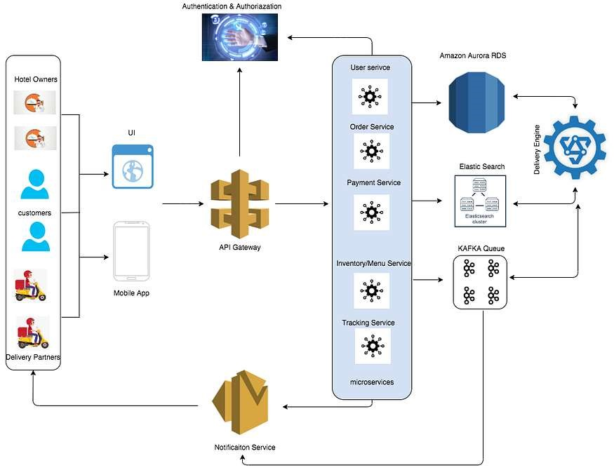

Here’s a high-level architecture for the project:

1. **Data Storage**: Databases are utilized by food delivery apps to store a variety of information including user details, restaurant data, and order records.
2. **Data Processing**: Leveraging data enables food delivery apps to enhance customer satisfaction, bolster brand reputation, and drive sales growth.
3. **Machine Learning**: Employing machine learning techniques, food delivery platforms refine their algorithms, tailoring experiences for users. For instance, Zomato utilizes machine learning for tasks like menu digitization, personalized restaurant recommendations, and predicting food preparation durations.
4. **Data Visualization**: Real-time visualization of processed data and predictive outcomes is facilitated through Power BI. This tool enables the creation of interactive dashboards, offering valuable insights into the data.
5. **Data Access**: Dashboards generated in Power BI are accessible through multiple channels including Power BI Desktop, Power BI Service (online), and Power BI Mobile.

While this architecture offers a holistic approach to real-time analysis for food delivery applications, it's crucial to acknowledge that its specifics might differ based on factors like the delivery network, particular needs, and financial considerations. Additionally, ensuring compliance with pertinent data privacy and security standards is imperative when selecting and implementing tools and services.

### CHAPTER 4



### MODELING AND RESULT

#### Manage relationship

The "cuisines" file serves as the primary link due to its inclusion of key identifiers such as Restaurant ID, Fact table, and Zomato global, facilitating the correlation of the four data files. Additionally, the "country code" file is utilized to establish a geographical connection between client profiles and "Zomato global."

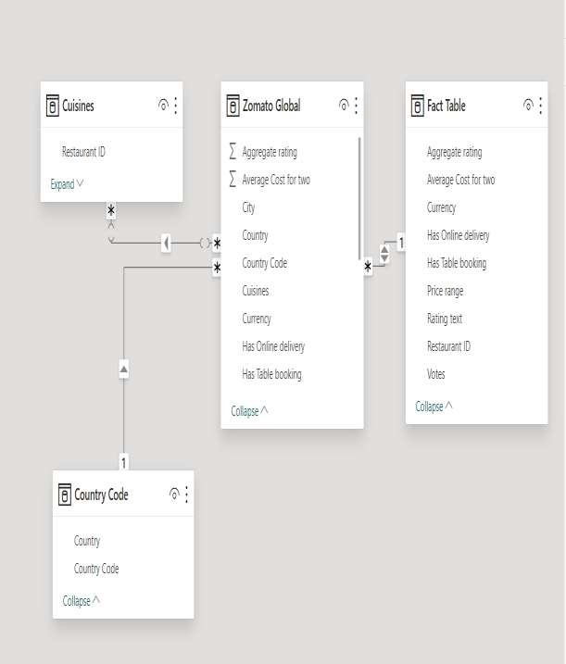

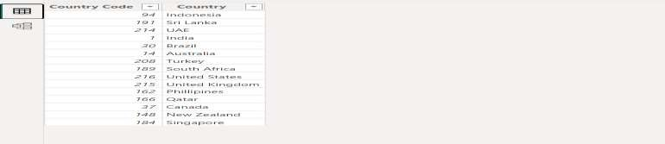

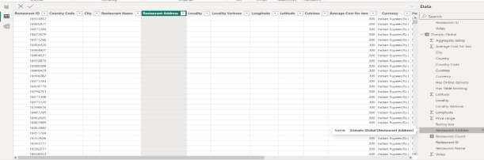

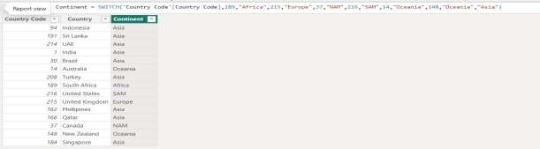

##### Modelling for Gender and Age data

It's worth noting the absence of gender and age data for clients in the dataset. However, these can be inferred from the birth number YYMMDD, where months with digits greater than 50 (found in the 3rd and 4th positions) typically indicate a female client. Consequently, we can generate a new column to represent gender based on this information.

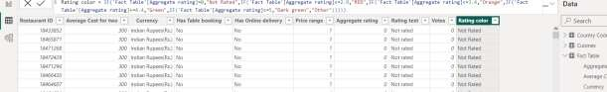

To determine the birthdate, we should subtract 50 from the birth month if the client is female. Then, we'll convert the date format to DD/MM/YYYY by adding 1900 to the year.

Regarding age calculation, we'll assume the birth year is 1999, as previously mentioned. We'll then subtract this assumed birth year from the actual birth year to determine the client's age.

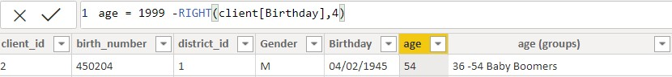

##### Replacing values

To enhance clarity and ease of understanding, certain fields will be translated to English by replacing their values using the Power Query Editor.

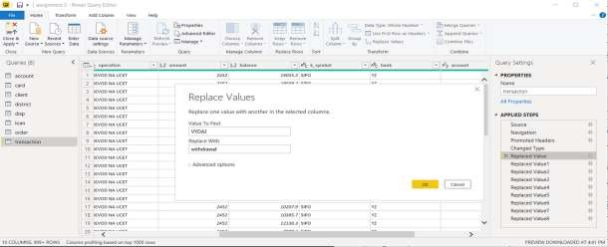

To rearrange the sequence of region names in Power Query, duplicate the "district/region" column, then split the column using a space as the delimiter.

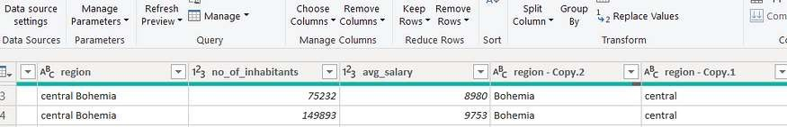

Then merge column by Region and direction. Refer to applied steps for details.

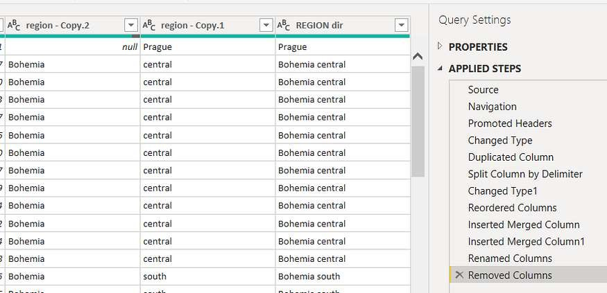

##### Grouping of age by ranges

To facilitate profiling, we'll categorize customers' ages, ranging from 12 to 88, into five distinct groups. These groups include Gen Y for youths, Gen X for young working adults, Baby Boomers for working adults with families, the Silent Generation comprising working and retired individuals living on pensions, and the Greatest Generation representing retired elderly individuals also relying on pensions. Additionally, certain fields such as "account Id" have been designated as text, while district names have been categorized based on their geographical location, enabling their use for mapping purposes to depict the total population in each region.

### Dashboard

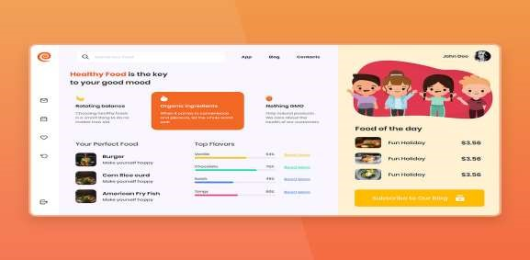

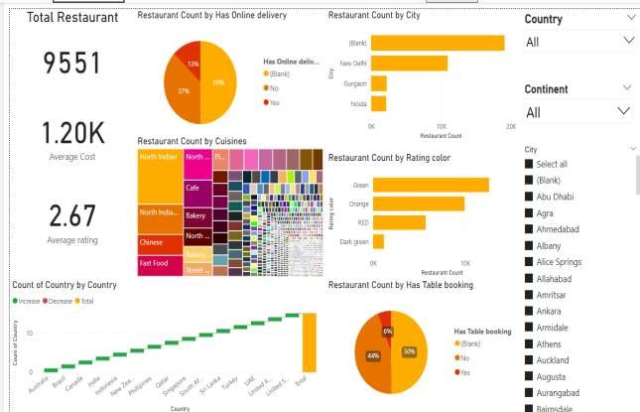

#### CONCLUSION

In today's era, traditional dining experiences have significantly declined as technology takes precedence in our daily lives. With the integration of software and technological gadgets, uncertainties are minimized, if not eliminated entirely. The modern preference leans towards swift, convenient, and secure access to various services. This project is meticulously crafted to cater to the needs of restaurants in this digital age. The Online Food Ordering System simplifies the process of storing customer details, available food items, and generating bills. It serves as a user-friendly interface, allowing customers to place orders for their desired meals, which can be enjoyed within a 45-minute timeframe.

In today's era, traditional dining experiences have significantly declined as technology takes precedence in our daily lives. With the integration of software and technological gadgets, uncertainties are minimized, if not eliminated entirely. The modern preference leans towards swift, convenient, and secure access to various services. This project is meticulously crafted to cater to the needs of restaurants in this digital age. The Online Food Ordering System simplifies the process of storing customer details, available food items, and generating bills. It serves as a user-friendly interface, allowing customers to place orders for their desired meals, which can be enjoyed within a 45-minute timeframe.

#### FUTURE SCOPE

The potential for future expansion of this project is vast. With the advancements in analytics and machine learning, Power BI holds the capability to forecast future trends by analyzing historical data. By integrating predictive analytics into the system, the bank could preemptively address customer needs and offer tailored solutions. Moreover, Power BI's versatility in integrating diverse data sources opens doors to incorporating a wider range of datasets, providing a more comprehensive understanding of customers.

As the importance of data privacy and security continues to grow, future iterations of this project should prioritize the implementation of robust data governance strategies. This ensures the safe handling of sensitive customer information while adhering to data protection regulations. Additionally, exploring the integration of real-time data streams could enhance the project's ability to deliver timely and relevant insights. This has the potential to revolutionize the way banks engage with their customers, ultimately leading to heightened satisfaction and loyalty.

#### REFERENCES

1. <https://cuzegbu.medium.com/ux-case-study-food-delivery-app-design-2a001c78db96>
2. <https://bootcamp.uxdesign.cc/ux-case-study-online-food-delivery-aac10a67d2e>

#### LINK

[**https://priyavarthini-raj.github.io/360-DEGREE-BUSINESS-ANALYSIS-OF-ONLINE-DELIVERY-APPS/**](https://priyavarthini-raj.github.io/360-DEGREE-BUSINESS-ANALYSIS-OF-ONLINE-DELIVERY-APPS/)